Lesson 2: The Myth of Prometheus

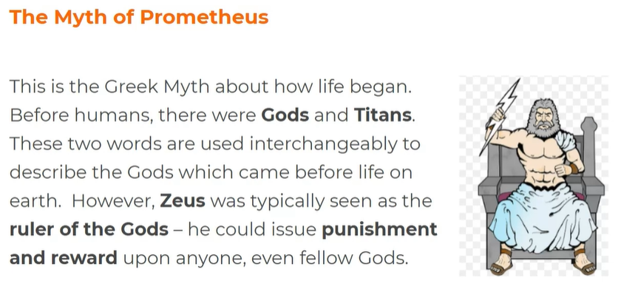
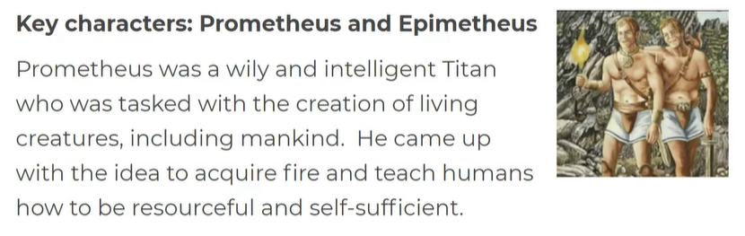
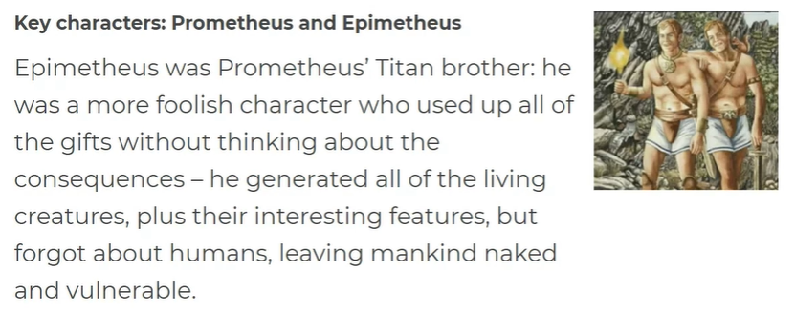
- Who was Zeus?

- Who was Prometheus?

- Who was Epimetheus?

- Read the story of Prometheus. Either while you read, or afterwards, answer the following questions:

  - Which two elements did Prometheus use to create mankind?

  - What was the Earth like during this myth?

  - From whose image did Prometheus create man?

  - How did Epimetheus feel about his brother’s new powers and responsibility?

  - What job did Prometheus give to Epimetheus?

  - What did Epimetheus forget to do?

  - What did Prometheus learn from the Gods?

  - What element was he gifted from the Gods?

  - How did Zeus feel about Prometheus’ actions?

  - What was Prometheus’ punishment?

