Lesson 1: Introduction to Greek Myths
- Read through this information, then note down three new ideas in your own words:
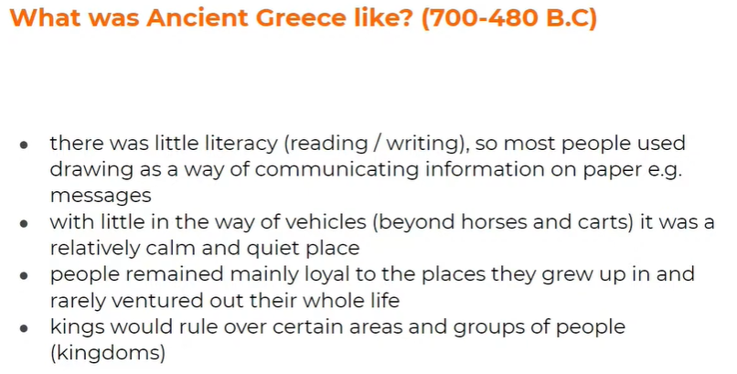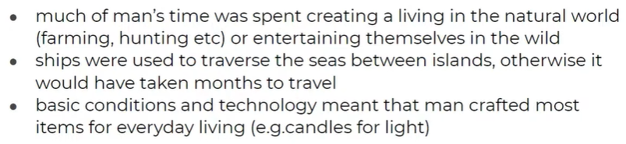

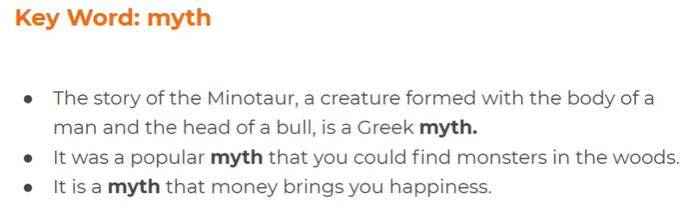
- Write down your own definition of ‘myth’, using the information above.

Check your answer here:
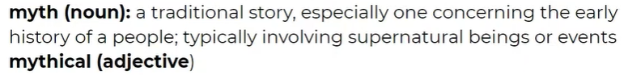
- Read the information below and then answer these questions:

  - What did the creation of myths allow mankind to do in ancient civilisations?

  - How was literacy (reading and writing) different in Ancient Greece?

  - What did the Ancient Greeks question?

  - What examples of characters did the Ancient Greeks use to tell their myths?

  - Why are Greek Myths important to us now?

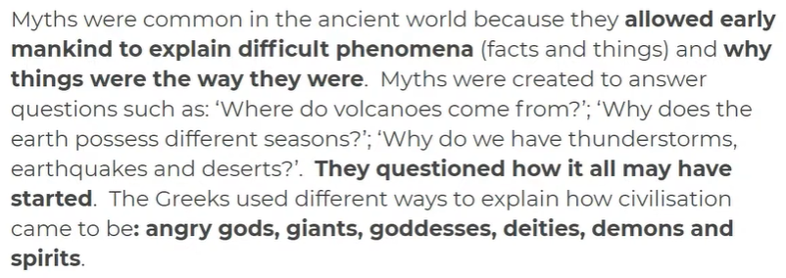
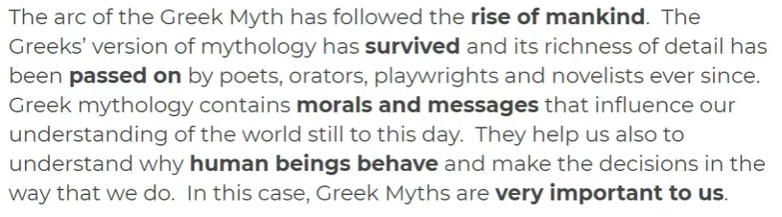

- (OPTIONAL ACTIVITY) Complete the sentences using the words ‘because’, ‘but’ and ‘so’. You can use the sentences from the video to help you:

  - The Greeks’ version of mythology has survived because…

  - Ancient Greek myths may be very old but…

  - There were few advanced inventions in Ancient Greece so…

- Read the definitions of the following concepts (key themes and ideas which appear often in Greek Myths):
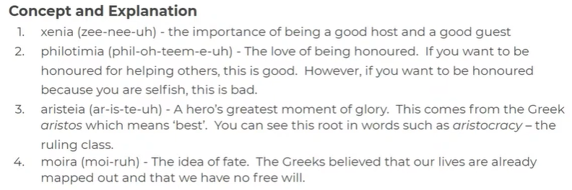

- Look at the plotlines on the video. Match each plotline to one of the concepts you have just learned about. Explain why it matches the concept.
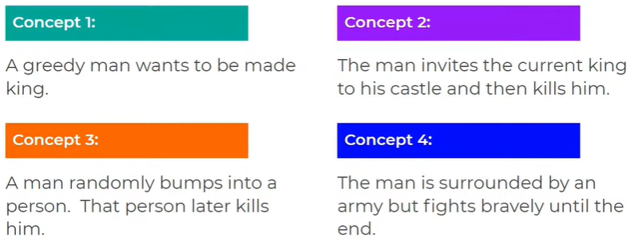

  - E.g. Plot 1 is an example of philotimia because this man might have wanted to become king because he wants to be honoured and revered by others.

  - Plot 2 is an example of …………………. because……..

  - Plot 3 is an example of …………………. because……..

  - Plot 4 is an example of …………………. because……..

