Lesson 1 - Gothic Conventions
Please complete the following tasks for your lesson today. There are ‘icons’ you can click on to hear the extracts being read out loud.
- Recap: Complete the table below with information about the Gothic. Use the images below, and/or the video to help you:
https://www.youtube.com/watch?v=HkzHppqXTds
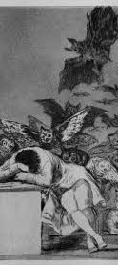
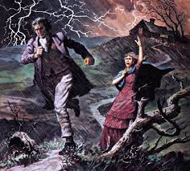
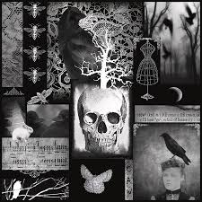
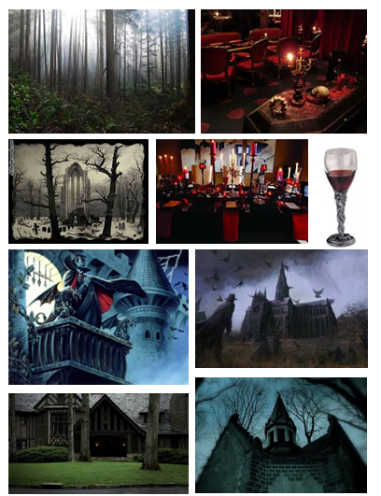

Gothic Convention | Examples
Settings | Abandoned houses,
Characters | Villains,
The Supernatural
Images/symbols | Crosses,

- Now, read the two extracts below from modern novels. Highlight any Gothic conventions you can find (some hints have been given to get you going):
Extract 1 – ‘Harry Potter and the Philosopher’s Stone’ by JK Rowling. At this point in the novel, Harry is in the Forbidden Forest and comes across an unexpected sight.
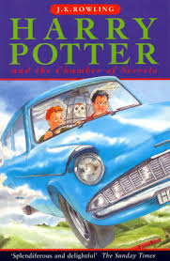
Something bright was gleaming on the ground. They inched closer. ​
It was the unicorn alright, and it was dead. Harry had never seen anything so beautiful and sad. Its long slender legs were stuck out at odd angles where it had fallen and its mane was spread pearly white on the dark leaves.​
Harry had taken one step towards it when a slithering sound made him freeze where he stood. A bush on the edge of the clearing quivered … Then, out of the shadows, a hooded figure came crawling across the ground like some stalking beast. Harry, Malfoy and Fang stood transfixed. The cloaked figure reached the unicorn, it lowered its head over the wound in the animal’s side, and began to drink its blood.
‘unicorns’ are mythical creatures – this could be part of the Gothic supernatural

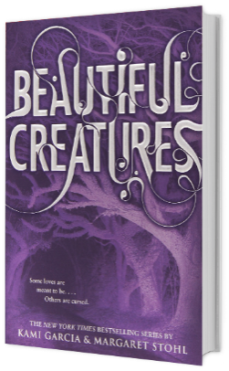
Extract 2: - ‘Beautiful
For a second, the sounds of the road and the rain and Link dissolved into silence, and it was like everything was moving in slow motion. I couldn’t drag my eyes away from the car. It was just a feeling, not anything I could describe. And then it slid past us, turning the other way.
I didn’t recognize the car. I had never seen it before. You can’t imagine how impossible that is, because I knew every single car in town. There were no tourists this time of year. They wouldn’t take the chance during hurricane season.
This car was long and black, like a hearse. Actually, I was pretty sure it was a hearse.
Maybe it was an omen. Maybe this year was going to be worse than I thought.
“Here it is. ‘Black Bandanna.’ This song’s gonna make me a star.”
By the time he looked up, the car was gone.
Creatures’ by Kami Garcia and Margaret Stohl

- Please choose one of the following tasks to finish your lesson:
  - Draw an image of modern Gothic setting:

  - Write a description of a Gothic character:

  - Make a list of as many modern books, TV shows and films as you can think of which contain elements of the Gothic. (this is a good place to start: https://www.youtube.com/watch?v=bLiXjaPqSyY)

