Core Knowledge Map
Subject: Mathematics | Year: 10 |  | Term: Autumn 1
What are we learning?
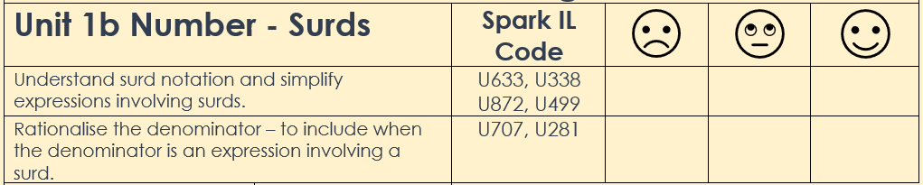
How will I be assessed
Retrieval Tasks, Exit Tickets, End of term test.
Big questions:
Can You….?
- Define an irrational number?
- Simplify √8 and $5\sqrt{2}+3\sqrt{18}+10\sqrt{50}$
- Rationalise: $\frac{1}{\sqrt{3}-1}$ and $\frac{1}{\sqrt{3}}$

How does this build on previous learning? |  | How will this link to my future learning?
- Calculating powers and roots  - Knowing square and cube numbers  - Using basic index rules |  | - Surds will appear in many future topics in GCSE such as in area and volume problems so you will need to be fluent in using them in calculations.  - Both surds and indices are used extensively at A Level
Core knowledge: |  | Key vocabulary:
An irrational number is a number that cannot be written in the form $\frac{a}{b}$where a and b are integers.  A surd is an irrational number.  Rules of indices:  - $n^{a}×n^{b}= n^{a+b}$  - $n^{a}÷n^{b}= n^{a-b}$  - ${\left(n^{a}\right)}^{b}=n^{ab}$  Know that, n⁰ = 1 and $n^{-1}=\frac{1}{n}$for positive integers n as well as, $n^{\frac{1}{2}}=\sqrt{n}$ and $n^{\frac{1}{3}}=\sqrt[3]{n}$ for any positive number n |  | Index (Indice)  Surd  Factor  Multiple  Lowest Common Multiple (LCM)  Highest Common Factor (HCF)  Simplify  Irrational  Rationalise  Standard Form  Square root  Root
Need more help? Use the Sparx Independent Learning Codes above

