Core Knowledge Map
Subject: Maths | Year: 9 Foundation |  | Term: Autumn 1
What are we learning?
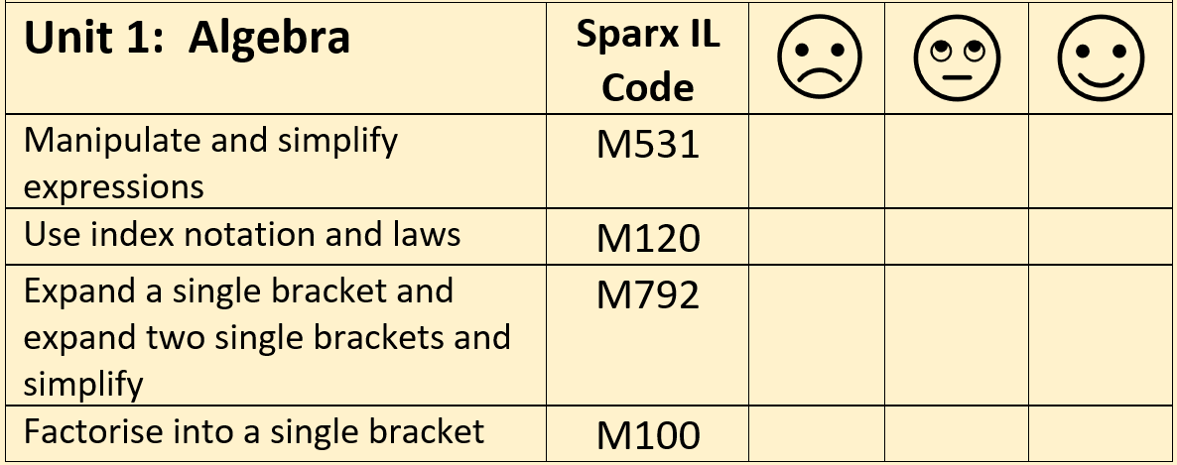
How will I be assessed
Topic Test at the end of the unit.
Big questions:
Write an expression for the number that is five less than x
Match-up unsimplified and simplified expressions
Expand and simplify 3(5x+2) – 4(2x–3)
Fully factorise:
- 3x+15
- 4x–10
- 2x² + 28
Simplify/find the value of:
- a³ x a⁶
- a¹⁰ ÷ a⁴
- (a²)³
- (3a⁴)²
- 23⁰
How does this build on previous learning? |  | How will this link to my future learning?
Algebraic notation  Negative numbers  Multiplying and dividing |  | Solving equations  Quadratic expressions/equations  Solving geometric problems
Core knowledge: |  | Key vocabulary:
An expression is a combination of numbers, variables and functions with operations.  An equation is a statement where two mathematical expressions are equal.  An identity is an equation that is true no matter what values are chosen.  A formula is a mathematical relationship or rule expressed in symbols.  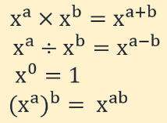  Index laws |  | Linear  Quadratic  Index  Indices  Factorise  Variable  Coefficient  Term  Expression  Simplify  Expand
Need more help? Use the Sparx Independent Learning Codes above.

