Core Knowledge Map
Subject: Business | Year: 11 |  | Term: Autumn 2
What are we learning?
2.4 Making Financial Decisions
How will I be assessed
Answering questions on Smart revise. Marked by teacher, peer and self. Assessment – 2.4 end of topic test - 45 mins
Big questions:
How does a business calculate and make judgement on their financial performance?
How does this build on previous learning? |  | How will this link to my future learning?
1.3 Putting a business idea into practice |  | A level business financial accounting or level 3 qualification in business.
Core knowledge: |  | Key vocabulary:
Quantitative skills  The concept and calculation of:  ● gross profit ● net profit  Calculation and interpretation of:  ● gross profit margin ● net profit margin ● average rate of return.  The use and interpretation of quantitative business data to support, inform and justify business decisions:  ● information from graphs and charts ● financial data ● marketing data ● market data.  The use and limitations of financial information in:  ● understanding business performance ● making business decisions. |  | Average rate of return  Gross profit  Gross profit margin  Market share  Net profit  Net profit margin  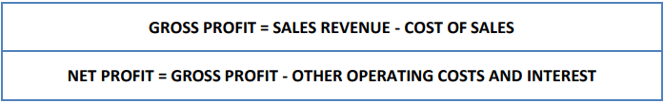  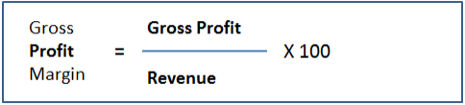  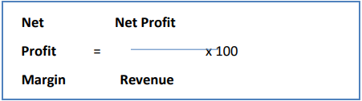  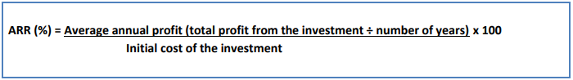
Need more help?
Google Website for revision maps, exam technique and revision guides. Business 9-1 - 2.4 (google.com)

