Dear student,
Welcome to Philosophy and Ethics! In September you will become part of a world tradition of free, critical thinking about the nature of the universe around us, our knowledge of it, and how one ought to live in it. It is a tradition as old as civilization.

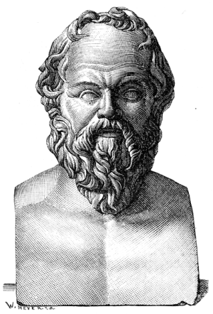
Holiday task
We would like you to read a short dialogue from the 4th century BC called Meno, by Plato, and write a review of it. Meno takes the form of a conversation between Socrates, a great Greek philosopher, and another man (called Meno) who thinks he knows everything, but soon finds out that he doesn’t know very much at all. It is very short and quite funny. There are various translations and editions about, and it doesn’t matter which one you use; lots of cheap editions are available to buy in bookshops, and I have put one on the W drive, in the ‘Philosophy and Ethics’ folder (‘Plato - Meno’).
Your review should:

- explain what the conversation between Socrates and Meno is about;
- give your interpretation of the big point Plato is trying to make; and
- give your view of whether Plato adequately proves his point.

It should be addressed primarily to your peers (others on the course), so use it to show off your intelligence and personality. Aim for about 1,000 words, but if you need more, go for it. We will read your essay to assess your suitability for the course and to work out your individual strengths and weaknesses. But it won’t be formally marked, so be creative!
We’re really looking forward to running this course with you next year, and look forward to seeing you again in September.

Yours sincerely,

Mrs E. White and Dr C. Fear

