Name:______________________

Year 12 BTEC Level 3
2016-2018

National Extended Certificate in Sport

Summer Holiday Study Programme

Anatomy and Physiology
Structure of the Skeleton.

Label the front of the skeleton.

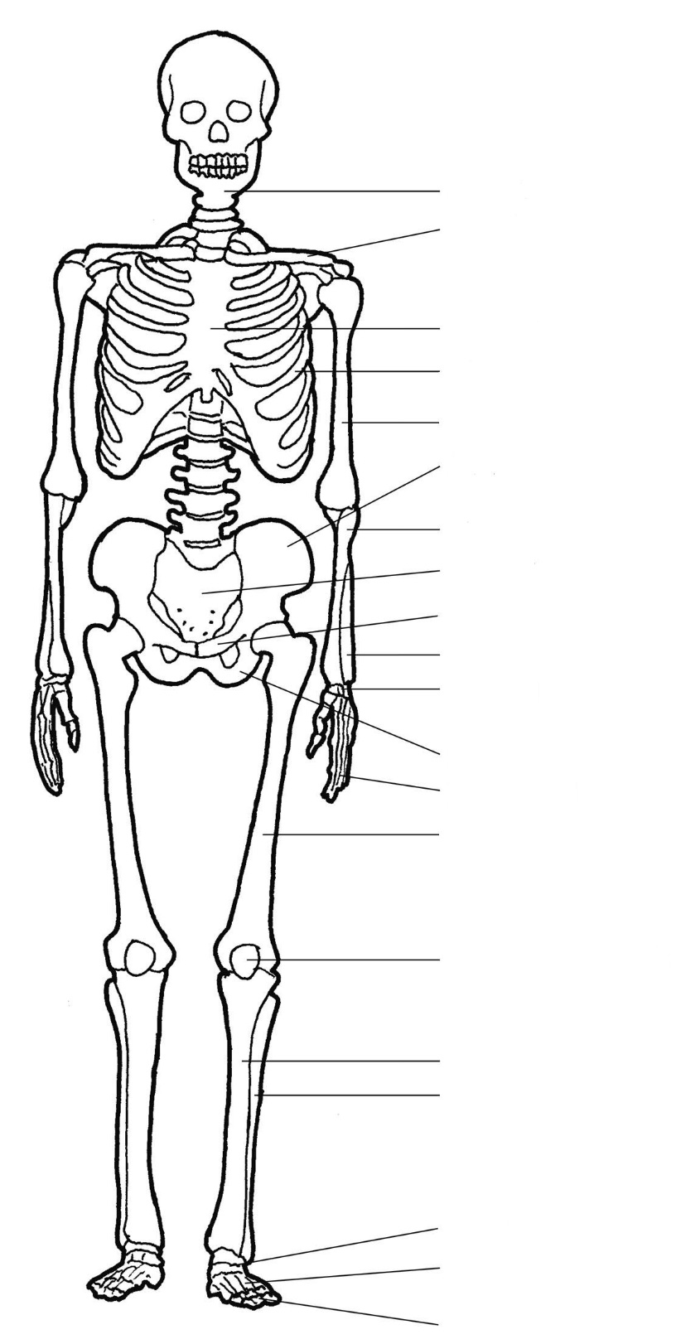
Anatomy and Physiology
Structure of the Skeleton.

Label the back of the skeleton.
On the diagram use colours to show the axial and appendicular skeleton.
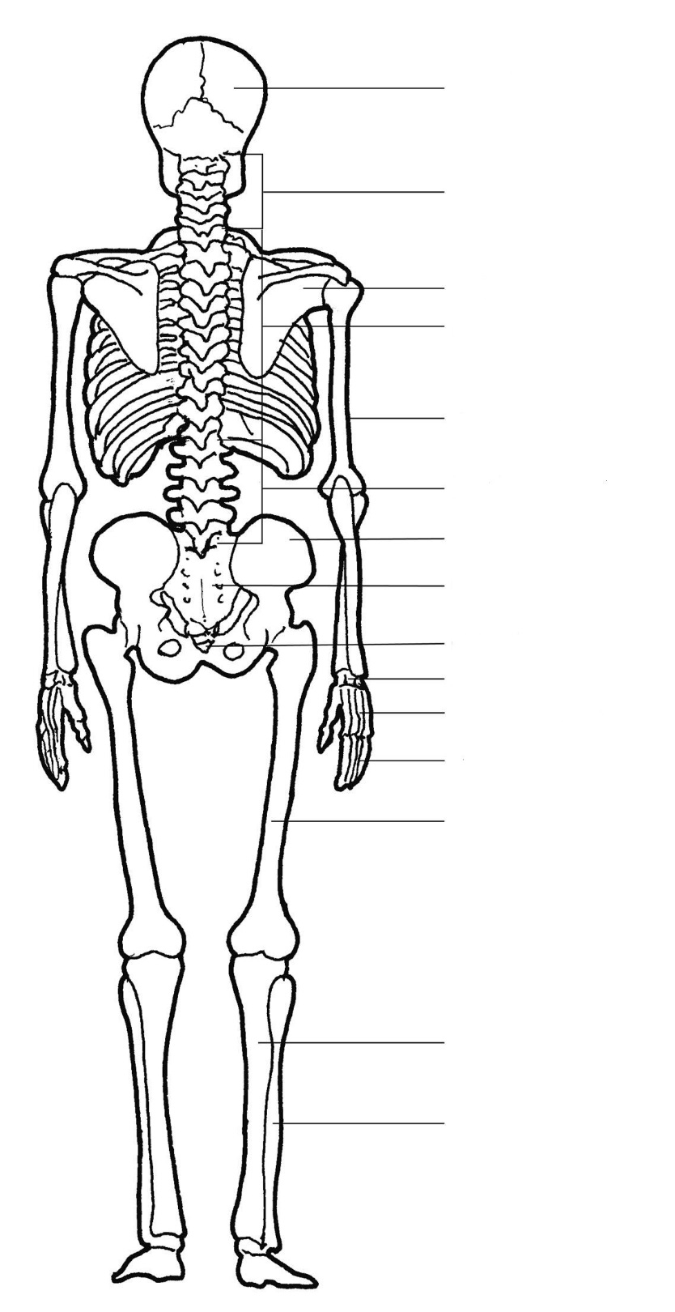
Anatomy and Physiology
Types of Bone

There are 5 different TYPES OF BONE that can be found in the body.

1. Identify what they are and give a description of each.
2. Underneath your description DRAW an example of this type of bone, complete with labels.
3. Finally, give an example for each type of bone explaining how they are used within different sporting techniques and actions (Try and use a different sport for each different type of bone.)

1.Type of Bone:_________________
Description:____________________________________________________________________________________________________________________________________________________________________________________________________________________________________________

Sporting Example:___________________________________________________________________ __________________________________________________________________________________

2.Type of Bone:_________________
Description:____________________________________________________________________________________________________________________________________________________________________________________________________________________________________________

Sporting Example:___________________________________________________________________ __________________________________________________________________________________
Anatomy and Physiology
Types of Bone cont.
3.Type of Bone:_________________
Description:____________________________________________________________________________________________________________________________________________________________________________________________________________________________________________

Sporting Example:___________________________________________________________________ __________________________________________________________________________________

4.Type of Bone:_________________
Description:____________________________________________________________________________________________________________________________________________________________________________________________________________________________________________

Sporting Example:________________________________________________________________ _______________________________________________________________________________
5.Type of Bone:__________________
Description:____________________________________________________________________________________________________________________________________________________________________________________________________________________________________________

Sporting Example:________________________________________________________________ _______________________________________________________________________________
Anatomy and Physiology
Types of Bone

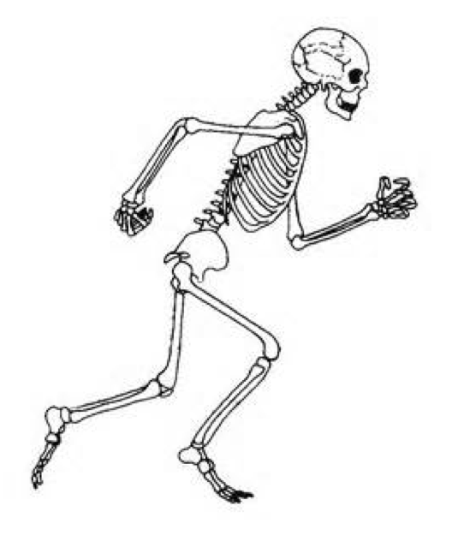
There are 5 different types of bone. Use different colours to identify the different types of bone on the diagram below. (Make sure you fill out the key at the bottom of the page).

KEY

Anatomy and Physiology
Research Task

Independently research and then create an information sheet about the following:
- The curvature of the spine
- The process of bone growth

Use labelled diagrams where appropriate and make sure you fully explain any key terms.
Be prepared to feedback your information to the rest of your group in our first lesson back in September.

