A LEVEL GEOGRAPHY SUMMER PROJECT

The following two tasks should take you a minimum of three hours to research and complete to the best of your ability. Do not return and say that you did one task, and not the other; both must be submitted at the same time. Although the third task is optional, it would be fantastic to be able to discuss the book as a class of geographers in September.

Task 1 (compulsory)

Listen to this podcast from the BBC’s ‘The Enquiry’ entitled ‘Can we quake-proof a city?’ http://www.bbc.co.uk/programmes/p03mqhzy
Read the associated BBC article http://www.bbc.co.uk/news/science-environment-35810317

After carrying your research, answer the following question;
Assess the extent to which it is possible to earthquake-proof a city. (10 marks)

Task 2 (compulsory)

There is a significant emphasis in the new A Level course on synopticity. Thinking synoptically means that you should be able to draw on your wider knowledge of geography to be able to make links between different concepts within the same question.
Read this article http://www.bbc.co.uk/news/blogs-news-from-elsewhere-39653873

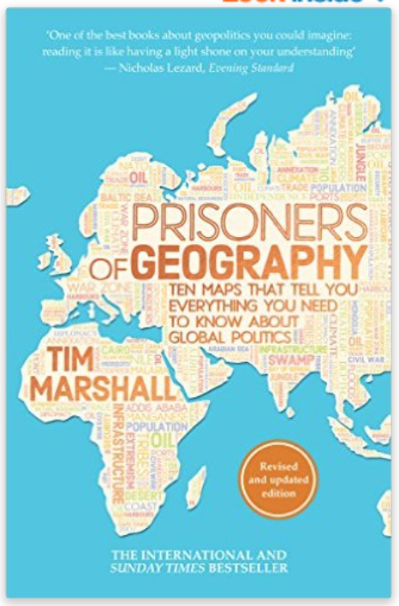
Explain how this is a good example of synopticity
(Think - What is the ‘geography’ in the article?)
Write one paragraph (4 marks).

Task 3 (optional)

The A Level course requires you to read and research wider geographical issues and debates independently. There is a recommended book for A Level students called ‘Prisoners of Geography’ by Tim Marshall, which is currently £4.99 on Amazon. I have a copy ready to read during my summer holiday too!

Email me if you have any questions about your summer tasks at jpayne@okehamptoncollege.devon.sch.uk

Good luck and have a great summer!

