Core Knowledge Map
Subject: Mathematics | Year: 10 |  | Term: Spring 2
What are we learning?
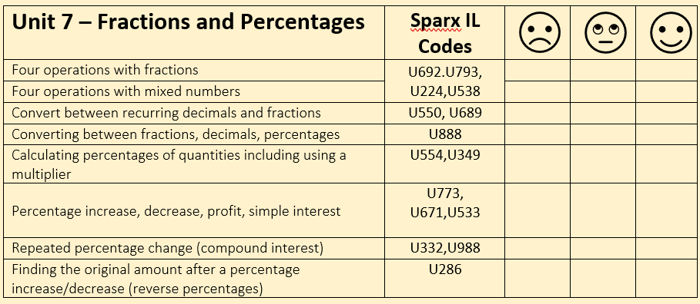
How will I be assessed
Retrieval Tasks, Exit tickets, end of half-term test.
Big questions:
Can you….?
- Write $\frac{2}{7}$ as a decimal (no calculator)
- Calculate $\frac{3}{5}$ + 1$\frac{2}{3}$ x 3 $\frac{3}{8}$
- What is the overall % change if an amount is increased by 30% then reduced by 20%
- Calculate the amount of simple interest earned on £2500 for 5 years at 3% per annum.
How does this build on previous learning? |  | How will this link to my future learning?
- Four operations with fractions and with mixed numbers  - Finding percentages of amounts  - Using multipliers for percentage change  - Simple Interest and Compound Interest.  - Finding percentage change  - Reverse percentage |  | - GCSE synoptic and multi-step problem solving questions.  - Percentages will feature in most careers and day to day life.
Core knowledge: |  | Key vocabulary:
Simple interest is an interest charge that borrowers pay lenders for a loan. It is calculated using the principal only and does not include compounding interest.  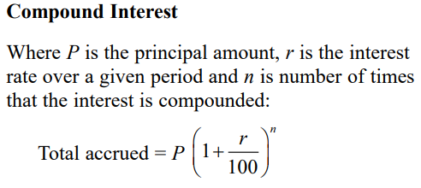 |  | Mixed number  Improper fraction  Multiplier  Compound interest  Recurring
Need more help? Use the Sparx Independent Learning Codes above

