Core Knowledge Map
Subject: Mathematics | Year: 10 |  | Term: Autumn 2
What are we learning?
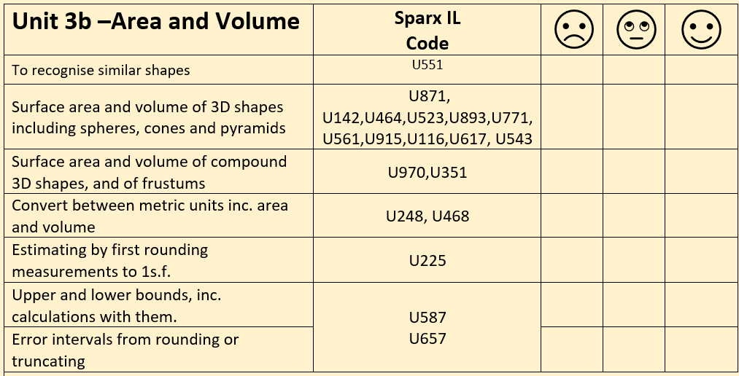
How will I be assessed
Retrieval Tasks, Exit tickets, end of half-term test.
Big questions:
Can you….?
- Convert 180 m³ to mm³
- Estimate 3850 $÷$ 0.56
- Describe the difference between rounding and truncating?
- Find the side length of a cube if its volume is 330.38 cm³
- Calculate the length of the diagonal in a cuboid with dimensions 5cm, 8cm, 9 cm.
- $x=y×z$.
$y=4.5$ correct to 1 decimal place. $z=3.68$ correct to 2 decimal places. Work out the lower and upper bound of $x$.

How does this build on previous learning? |  | How will this link to my future learning?
- Recall how to find the volume of cube/cuboid/prism and cylinder  - Use of Pythagoras’ theorem.  - Use of trigonometry ratios.  - Conversion of metric length units |  | - GCSE synoptic and multi-step problem solving questions.  - Volumes appear in A level maths where we look at optimisation problems and rate of change problems involving 3D shapes.
Core knowledge: |  | Key vocabulary:
Volume of a cube or cuboid = $b ×h×l$  Volume of prism = $Area of cross section x l$  Volume of a pyramid = $\frac{1}{3}Ah$ where A is the area of the base and h is the perpendicular height |  | Volume  Surface area  Plane  Sphere, Hemisphere, Cone, Pyramid, Cylinder  Perpendicular  Frustum  Truncated  Upper bound and Lower bound  Similar
Need more help? Use the Sparx Independent Learning Codes above

