Core Knowledge Map
Subject: Mathematics | Year: 10 |  | Term: Autumn 1
What are we learning?
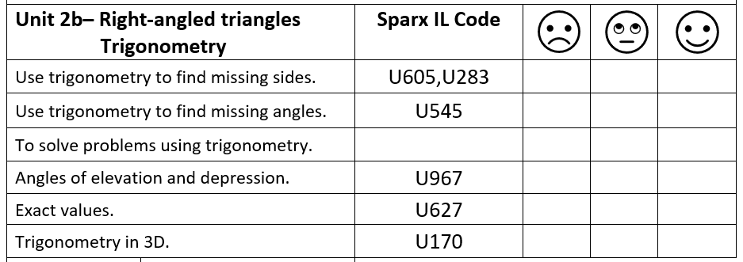
How will I be assessed
Retrieval Tasks, Exit tickets, end of half-term test.
Big questions:
Can You….?
- Describe the hypotenuse in a right-angled triangle.
- Without a calculator – what is the value of sin(60), tan(45), cos(60)?
- Calculate length x giving your answer to 1dp.
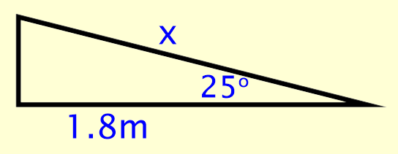
- A window cleaner has a ladder which is 7m long. The window cleaner leans it against a wall so that the foot of the ladder is 3m from the wall. What angle does the ladder make with the wall?

How does this build on previous learning? |  | How will this link to my future learning?
- Using a calculator efficiently  - Rounding  - Substituting values into formula  - Rearranging formula  - Solving equations  - Use of surds |  | - Using both Pythgoras’ theorem and the trigonometric ratios in synoptic questions.  - Using trigonometry in non right angled triangles in Year 11  - Both are used extensively at A-Level
Core knowledge: |  | Key vocabulary:
- To recall and use the three main trigonometric ratios:  $sinθ= \frac{opp}{hyp}$, $cosθ= \frac{adj}{hyp}$ , $tanθ= \frac{opp}{adj}$  - An inverse function ‘undoes’ the original function.  - A plane is a two dimensional space or flat surface.  - Exact values |  | Trigonometry  Sine, Cosine and Tangent  Hypotenuse  Opposite  Adjacent  Theorem  Similar  Inverse  Plane  Elevation  Depression
Need more help? Use the Sparx Independent Learning Codes above

