Core Knowledge Map
Subject: Mathematics | Year: 10 |  | Term: Autumn 1
What are we learning?
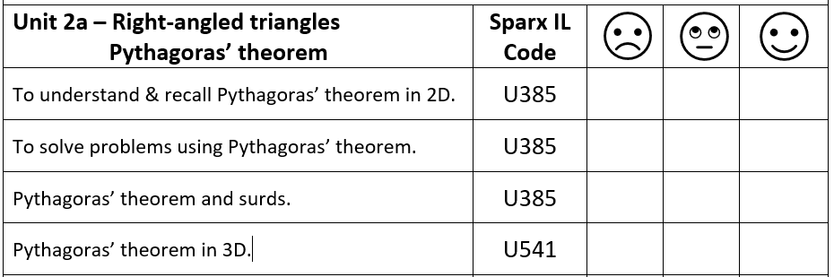
How will I be assessed
Retrieval Tasks, Exit tickets, end of half-term test.
Big questions:
Can You….?
- Deduce of a triangle with side lengths, 2,3 and 6 is a right-angled triangle?
- Find the length between two coordinate points (2,3) and (8,13)?
- Describe when you use the version $a^{2}= c^{2}- b^{2}$ ?
- Calculate lengths x and y giving your answer to 1 dp
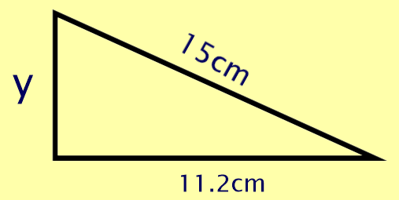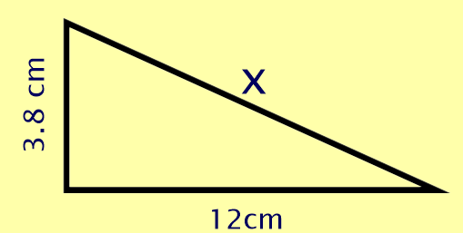

How does this build on previous learning? |  | How will this link to my future learning?
- Using a calculator efficiently  - Rounding  - Substituting values into formula  - Rearranging formula  - Solving equations  - Use of surds  - Recall formula and usage from Year 9 |  | - Using both Pythgoras’ theorem and the trigonometric ratios in synoptic questions.  - Using trigonometry in non right angled triangles in Year 11  - Both are used extensively at A-Level
Core knowledge: |  | Key vocabulary:
Pythagoras’ theorem states c² = a² + b² where c is the length of the hypotenuse in a right-angled triangle.  Volume of a cuboid = $\sqrt{a^{2}+ b^{2}+ c^{2}}$ |  | Trigonometry  Hypotenuse  Opposite  Adjacent  Theorem  Angle of elevation  Angle of depression  Similar  Inverse  Pythagorarean Triple
Need more help? Use the Sparx Independent Learning Codes above

