Introduction to
BTEC Level 3
National Extended Certificate in
Applied Science
OKEHAMPTON COLLEGE
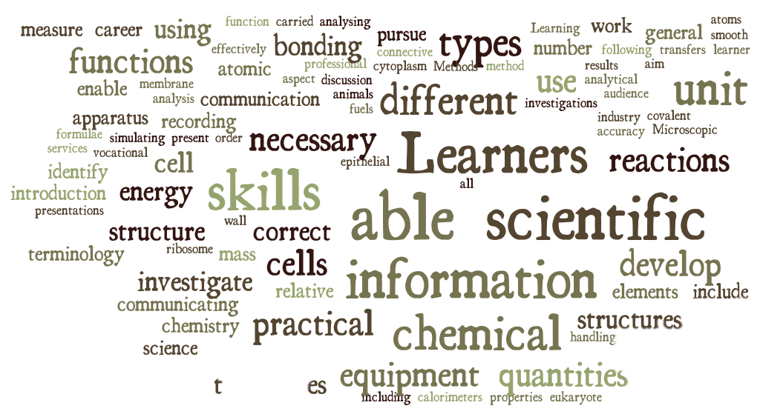
Applied Science
BTEC Level 3 National Extended Certificate

What is the subject about?
BTEC Applied Science covers the fundamental scientific principles of Biology, Chemistry and Physics and how they are applied to modern industrial practices and research techniques. You will not only gain a solid grounding in scientific theories and concepts but also develop the practical, investigative skills that underpin this sector.

This includes: how cells are designed to fulfil a particular function within the body and to build tissues and organ systems; atomic structure and the application of structure and bonding in science; waves, their uses and importance within the modern technological age; the physiology of the musculoskeletal system and disorders associated with it. In this course you will develop essential knowledge and understanding of fundamental biological, chemical and physical concepts, as well as the practical application of these in the scientific workplace.

How is the course structured?
You will study 4 units over the space of 2 years. Unit 1 and 3 are the externally examined and assessed units and will be undertaken in the first year. Units 2 and 8 are coursework based and will be completed in the second year. The course is taught by two teachers, each teaching 2 hours per week, each setting an additional 2 hours of guided study time in which you should be completing your assignments and other tasks set.

The units are as follows:
Unit 1 – Principles and Applications of Science
Unit 2 – Practical Scientific Procedures and Techniques
Unit 3 – Science Investigation Skills
Unit 8 – Physiology of Human Body Systems

How is the course assessed?
Unit 1 is assessed through a 90 minute written theory exam, externally set and marked.
Unit 3 is similarly assessed through a 90 minute written test, externally set and marked but based on scientific investigation carried out by you.
Units 2 and 8 are assessed by a series of assignments set by your teacher. They are broken down into tasks in order for you to meet the necessary criteria to achieve Pass, Merit or Distinction level.

These tasks may take the form of a practical task for which your teacher will complete a formal observation as evidence you have met the criteria. You may be required to give a presentation to the group, produce a poster, leaflet or scientific report or to produce annotated images of work you have completed.

What skills will I need and develop in this course?
You will need to be extremely well organised and be able to meet deadlines on a weekly basis. You will develop your ability to work as a team as well as conducting independent research and develop your communication and presentation skills. You will also develop your practical and research skills – i.e. how to find relevant scientific information and how to analyse and evaluate scientific data.

IMPORTANT:
We strongly advise you have a DIARY to keep a record of ALL upcoming deadlines to ensure you do not fall behind with work.

What Qualification will I come away with?
At the end of Year 13 you will have completed the BTEC Level 3 National Extended Certificate in Applied Science. This is made up of the mandatory Units 1, 2 and 3 and the additional Unit 8.

What can the course lead to in terms of higher education and future careers?
The Pearson BTEC Level 3 National Extended Certificate in Applied Science is intended as an Applied general qualification for post-16 learners who want to continue their education through applied learning and who aim to progress to higher education and ultimately to employment, possibly in the applied science sector.
The requirements of the qualification will mean that you develop the transferable and higher order skills which are valued by higher education providers and employers. For example, when studying Unit 3: Science Investigation Skills, you will develop skills including how to plan
investigations, collecting, analysing, and presenting data and communicating results which support some of the skills you need to progress to higher education, employment, self-employment or training.
This course is an excellent foundation for further study of physiotherapy, nursing, engineering and related subjects such as pharmacology and biomedical sciences. It is also highly recommended for other sciences. This course also provides valuable experience and insight into how these professions are carried out, the daily procedures staff in these roles need to follow and how to work safely in a number of scientific roles.

What are the formal entry requirements for this course?
To ensure you have a reasonable chance of success our recommendation is at least a B grade in GCSE Science and Additional Science (or Additional Applied Science).

Why should I consider taking BTEC Applied Science Level 3 National Extended Certificate?
BTEC Applied Science is a great foundation for those wishing to pursue a career in the sciences or those thinking of going on to higher education. It will give you practical experience of the procedures commonly used in the science industry including:
- Analytical chemistry techniques
- Developing the skills required plan and carryout a scientific investigation
- The use of microscopes in practical science
- Investigating factors that can affect plant growth and/or distribution
- Investigating the energy content of fuels
- Explore the physiology of the digestive system and the use of corrective treatments for dietary-related diseases

One key aspect of the course is the potential for visiting research facilities, manufacturing premises and other scientific organisations in order to see first-hand how the procedures you will carry out in college are done on an industrial scale. Some of these opportunities will enable further hands on experience and allow you to fully appreciate how these techniques are used on a day to day basis.

Course prerequisite:
In order to ensure you have the required academic ability and work ethos required to succeed you must complete the task below and bring your completed work to the first BTEC lesson in September 2017. You are expected to spend at least 3 hours on this task and will also need to submit your work electronically to rbertram@okehamptoncollege.devon.sch.uk

Failure to complete the tasks to a suitable level will result in not being enrolled onto the course.

SUMMER TASK
Your Challenge
Prepare a written report based on one of the following questions. You will carry out your own research and then hand your work in during the first lesson back in September. Your work can be presented in any format of your choice. Remember, you are demonstrating your ability to work independently and produce work to the standard required at post 16. Choose from:
Biology
- The history of the microscope
- The differences between light and electron microscopes
Physics
- The application of fibre optics in medicine (to include endoscopes).
- The application of fibre optics in communication (to include analogue-to-digital conversion and broadband).

Definitions of the common command words used in the grading criteria:
Analyse - Identify separate factors, say how they are related and how each one contributes to the topic.
Appraise - Consider the positive and negative points and give a reasoned judgement
Assess - Give careful consideration to all the factors or events that apply and identify which are the most important or relevant; to determine the importance, size, or value of something
Comment - Give your view after you have considered all the evidence. In particular decide the importance of all the relevant positive and negative aspects
Compare - Identify the main factors that apply in two or more situations and explain the similarities and differences or advantages and disadvantages
Contrast - Show differences
Criticise - Review a topic or issue objectively and weigh up both positive and negative points before making a decision
Define - Clearly explain what a particular term means and give an example, if appropriate, to show what you mean
Demonstrate - Provide several relevant examples or related evidence which clearly support the arguments you are making. This may include showing practical skills
Describe - Give a clear description that includes all the relevant features - think of it as ‘painting a picture with words’. A detailed account
Design - Create a plan, proposal or outline to illustrate a straightforward concept or Idea
Draw - Use the evidence you have provided to reach a reasoned judgement Conclusions
Explain - Set out in detail the meaning of something, with reasons. More difficult than describe or list; it can help to give an example to show what you mean. Start by introducing the topic then give the ‘how’ or ‘why’. OR provide details and give reasons and/or evidence to clearly support the argument you are making
Evaluate - Review the information then bring it together to form a conclusion. Give evidence for each of your views or statements
Evaluate - Make clear; intelligible; a definite and precise account for critically
Identify - Point out or choose the right one / give a list of the main features
Illustrate - Include examples or a diagram to show what you mean
Interpret - Define or explain the meaning of something (words, actions, etc)
Investigate - Inquire into; examine; investigate by going through it (Explore)
Justify - Give reasons or evidence to support your opinion or view to show how you arrived at these conclusions. Prove right; vindicate.
List - Provide the information in a list, rather than in continuous writing
Outline - Write a clear description; give a summary of / a general plan showing essential features but no detail
Plan - Work out and plan how you would carry out a task or activity
State - Provide a clear and full account in speech or writing
Summarise - Write down or articulate briefly the main points or essential features

