Core Knowledge Map
Subject: Mathematics | Year: 10 |  | Term: Autumn 1
What are we learning?
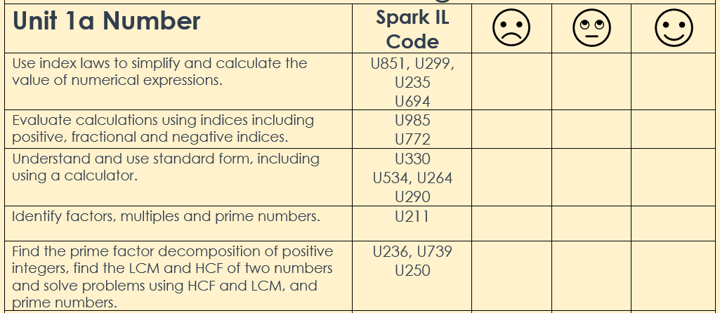
How will I be assessed
Retrieval Tasks, Exit tickets, end of half-term test.
Big questions:
Can You….?
- Write down the value of 2⁵
- Prove that the square root of 45 lies between 6 and 7
- Evaluate (2³ × 2⁵) ÷ 2⁴
- Work out the value of n in 40 = 5 × 2^{n}
- Write 365,000,000,000 and 0.0000004653 in standard form.
- Calculate (1.6 x 10⁶) ÷ (6.4 x 10⁻⁸) giving your answer in standard form
- Write any number as a unique produce of its prime factors
- Use a Venn diagram to sort information to find HCF and LCM
- Recall prime numbers up to 100

How does this build on previous learning? |  | How will this link to my future learning?
- Calculating powers and roots  - Finding factors and prime factors of a number.  - Finding HCF and LCM of a number  - Using basic index rules  - Convert large and small numbers to standard form. |  | - Numbers written in standard form can appear elsewhere in the curriculum.  - Index numbers appear in many topics and in standard formulae.  - Indices are used extensively at A Level
Core knowledge: |  | Key vocabulary:
factor of a number or algebraic expression divides that number or expression evenly with no remainder.  A multiple is the product result of one number multiplied by another number.  A prime number only has two factors, itself and one.  Rules of indices:  - $n^{a}×n^{b}= n^{a+b}$  - $n^{a}÷n^{b}= n^{a-b}$  - ${\left(n^{a}\right)}^{b}=n^{ab}$  Know that, n⁰ = 1 and $n^{-1}=\frac{1}{n}$for positive integers n as well as, $n^{\frac{1}{2}}=\sqrt{n}$ and $n^{\frac{1}{3}}=\sqrt[3]{n}$ for any positive number. |  | Index (Indice)  Factor  Multiple  Lowest Common Multiple (LCM)  Highest Common Factor (HCF)  Simplify  Standard Form  Square root  Root
Need more help? Use the Sparx Independent Learning Codes above

