Introduction to
A level Physics
OKEHAMPTON COLLEGE
Physics
A Level

What is the subject about?
Physics is the study of nature; it aims to understand particles, energy, forces and fields on both the smallest and largest scales, from the interaction of the smallest particles yet discovered to the way the Universe has evolved since the beginning of time. Alongside these fundamental aspects, we will also cover topics more relevant to our daily lives and see how Physics underpins much of the technology we have come to rely on in the modern world, and has inspired the digital revolution.

For A level Year 1 you will study:
In the first year we begin by studying how Physicists make measurements of the natural world, and consider the uncertainties and errors associated with these measurements. We will look at the fundamental particles and forces that our Universe is made up from, and how those particles interact. We will go on to look at wave behaviour, materials and how objects move, as well as increasing our understanding of electricity from GCSE level.

For A level Year 2 you will study:
A level Year 2 we will continue to look at motion in more detail. We will study thermodynamics and gas laws, as well as the molecular kinetic theory model. We will also cover uniform and non-uniform fields, both electric and gravitational and see how these fields dominate the landscape of the Universe on both the small and large scale. We will then consider electromagnetic machines and electrical components in order to begin to understand the technologies that are ubiquitous in the modern world.

How is the course assessed?
Year 1 – internal examination at the end of Year 1
A level – 100% examination at the end of Year 2 plus a practical endorsement assessed over the 2 years.

What skills will I need and develop in this course?
The most important skill for a Physicist is to be able to think logically and solve problems that are posed in new and unfamiliar circumstances, and the A level Physics course will develop your ability to do this. You will need to have a reasonable degree of mathematical skill, and practical investigation skills are very important.

Subject combination advice:
We strongly advise you to take maths and another science subject (especially if you are considering medicine) as many science degree courses related to Physics require maths and two sciences at the top universities.

What can the course lead to in terms of higher education and future careers?
This course is an excellent foundation (and indeed essential) for further study of Physics, astrophysics, a whole range of engineering degrees, medical physics and medicine. The problem solving skills you will develop in Physics could lead to careers in all sorts of areas such as research and development, design, sustainable energy, telecommunications, meteorology, law, finance, media technology, computer gaming design, transport and education. It is also highly recommended for other science degrees and maths.

What are the formal entry requirements for this course?
A level Physics is both a theory and practical based course that is assessed by exams and internal controlled practicals and builds directly on GCSE work in Physics and Maths. National evidence suggests it is difficult to succeed unless you have an appropriate base of knowledge and a good track-record of success in exam based courses at GCSE. To ensure you have a reasonable chance of success our recommendation is at least BB in GCSE Science and Additional Science (or B in GCSE Physics with a B grade in either Biology or Chemistry) together with 6 in GCSE Maths (Higher Level).

Why should I consider taking an A level in Physics?
For many Physicists their major motivation is the pursuit of the knowledge and understanding of the laws that govern our Universe. However beyond this, Physics teaches you transferable skills and allows you to approach new problems from a point of logic, which is why it can lead to such a huge range of careers. Many of the challenges facing society today will be solved by people who have Physics training, whether it is in solving the energy crisis, climate change or developing new treatments for disease, Physics can equip you to take on these enormous tasks. Much of the technology we rely upon today evolved directly from discoveries made by Physicists, and so the study of more fundamental Physics such as the particle model or astrophysics could yet lead to unimagined solutions to some of today’s problems. If you would like to know more about the nature of the Universe and develop skills that will help you to forge a career that can make a difference to others then Physics is a fantastic choice.

Course prerequisite:
In order to ensure you have the required academic ability and work ethos required to succeed on the A-level Physics course you must complete the tasks below and bring your completed answers to the first Physics lesson in September 2017. You may be able to answer some of the questions using your GCSE knowledge; however you may have to search online for further information to answer all of the questions. Failure to complete the tasks to a suitable level will result in not being enrolled onto the course.

Physics questions
Activity 1: Waves

- a Define the amplitude of a wave.

(1 mark)
b i Other than electromagnetic radiation, give one example of a wave that is transverse.
(1 mark)
ii State one difference between a transverse wave and a longitudinal wave.

(1 mark)
c Figure 1 shows two identical polarising filters, A and B, and an unpolarised light source. The arrows indicate the plane in which the electric field of the wave oscillates.
    - If polarised light is reaching the observer, draw the direction of the transmission axis on filter B in Figure 1.
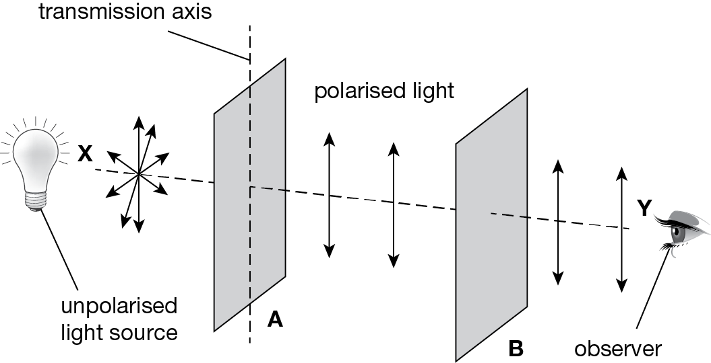
Figure 1 (1 mark)
    - The polarising filter B is rotated clockwise through 360° about line XY from the position shown in Figure 2. On the axes below, sketch how the light intensity reaching the observer varies as this is done.
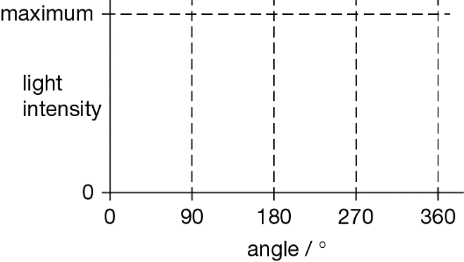
Figure 2
(2 marks)
Activity 2: Electricity

- a A semiconducting diode is an example of a non-ohmic component. State what is meant by a non-ohmic component.

(1 mark)
b A filament lamp is also an example of a non-ohmic component.
    - Sketch on the axes below the current–voltage characteristic for a filament lamp.
(2 marks)
    - State, with reference to the current–voltage characteristic you have drawn, how the resistance of the lamp changes as the pd across its terminals changes.

(1 mark)
c A filament lamp has a power rating of 36 W when there is a pd across its terminals of 12 V.
    - Calculate the resistance of the filament when the pd across its terminals is 12 V.

answer = Ω
(2 marks)

Activity 3: Forces

- a i State the difference between a scalar quantity and a vector quantity.

(1 mark)
ii State two examples of a scalar quantity and two examples of a vector quantity.
scalar quantities
vector quantities
(3 marks)
b Figure 1 shows a ship fitted with a sail attached to a cable. The force of the wind on the sail assists the driving force of the ship’s propellers.
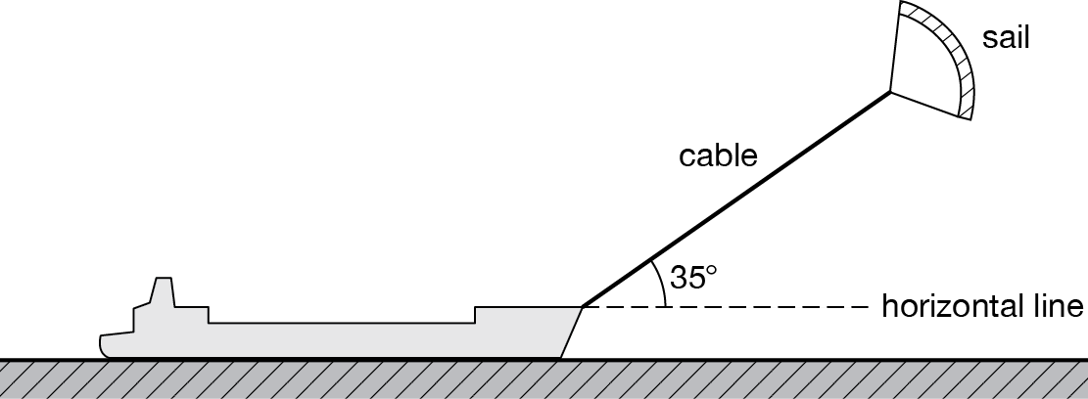
Figure 1
The cable exerts a steady force of 2.8 kN on the ship at an angle of 35° above a horizontal line.
Calculate the horizontal and vertical components of this force.

horizontal component of force kN
vertical component of force kN
(2 marks)

Activity 4: Motion

- A car is travelling on a level road at a speed of 15.0 m s^{–1} towards a set of traffic lights when the lights turn red. The driver applies the brakes 0.5 s after seeing the lights turn red and stops the car at the traffic lights. Table 1 shows how the speed of the car changes from when the traffic lights turn red.
Table 1
Time / s | 0.0 | 0.5 | 1.0 | 1.5 | 2.0 | 2.5 | 3.0 | 3.5
Speed / m s^{–1} | 15.0 | 15.0 | 12.5 | 10.0 | 7.5 | 5.0 | 2.5 | 0.0
a Draw a graph of speed on the y-axis against time on the x-axis on the grid provided.
(5 marks)
b i State and explain what feature of the graph shows that the car’s deceleration was uniform.

(2 marks)

ii Use your graph to calculate the distance the car travelled after the lights turned red to when it stopped.

Answer m (4 marks)

From AQA Physics A PHYA2 Mechanics, Materials and Waves January 2009 (Question 1)

- The distance–time graphs for two runners, A and B, in a 100 m race are shown in Figure 2.
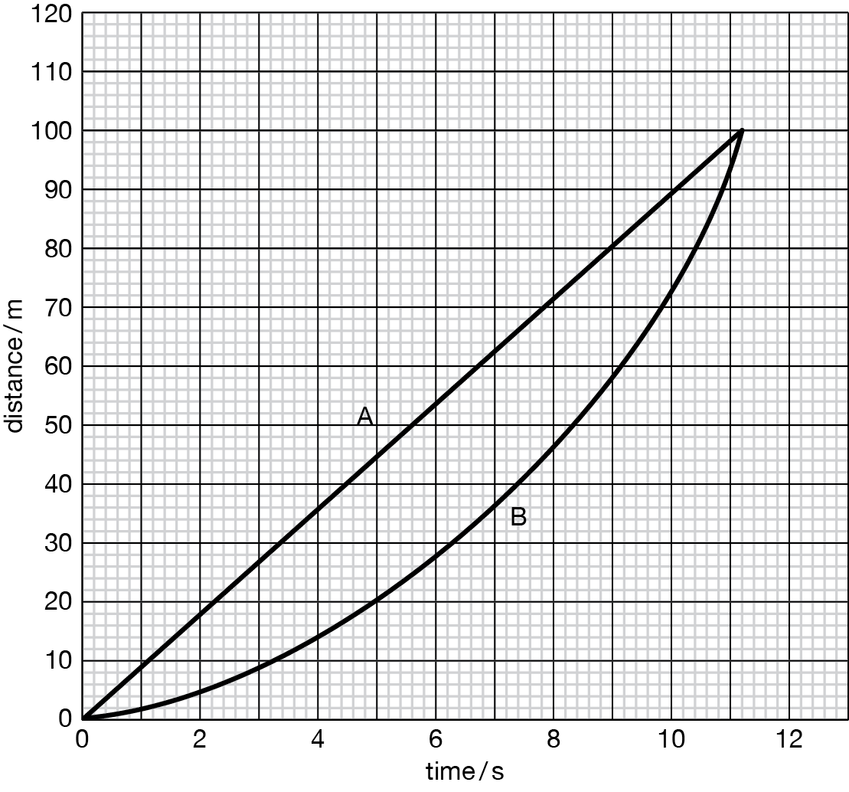
Figure 2
a Explain how the graph shows that athlete B accelerates throughout the race.

(1 mark)
b Estimate the maximum distance between the athletes.
(1 mark)
c Calculate the speed of athlete A during the race.
(1 mark)
d The acceleration of athlete B is uniform for the duration of the race.
i State what is meant by uniform acceleration.

ii Calculate the acceleration of athlete B.

(3 marks)

From AQA Physics A PA02 Mechanics and Molecular Kinetic Theory June 2007 (Question 1)

Activity 5: Making Measurements
Metals such as steel do not stretch easily. You need a large stress to stretch the wire – this means the wire must be very thin and you need a large force. Steel only behaves elastically for very small strains so you need a very long wire to produce a measureable extension.
We need to use specialist equipment to be able to measure small increments in a precise and accurate way.
Two important pieces of equipment are a vernier and a micrometer.
- Define precision

- Define accuracy

- Describe how each device is used to measure the diameter and cross-sectional area of a piece of wire that is being stretched. You may use diagrams to support your answers.

You are investigating how the stress and strain of a piece of wire changes as you add weights to it. You measure the cross-sectional area and length of the wire in the morning. At midday you begin your investigation, measuring the extension as you increase the force added. Suggest and explain how the accuracy of your calculations of stress and strain could be affected by your method.

