Core Knowledge Map
Subject: Maths | Year: 9 Higher |  | Term: Autumn 1
What are we learning?
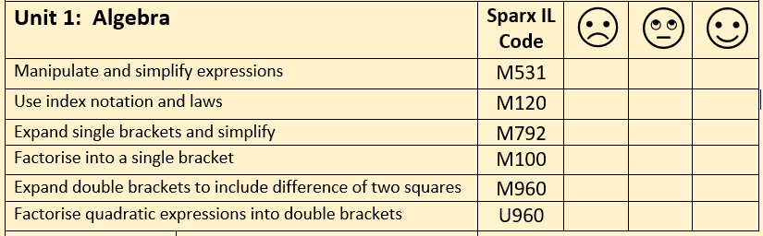
How will I be assessed?
Topic Test at the end of the unit.
Big questions:
Write an expression for the number that is five less than x
Expand and simplify 3(5x+2) – 4(2x–3)
Expand and simplify (x+3)(x-7)
Fully factorise:
  - 3x+15
  - 4x–10
  - 2x²+12x
  - x²+8x+15

Simplify/find the value of:
  - a³ x a⁶
  - a¹⁰ ÷ a⁴
  - (3a⁴)²
  - 23⁰
  - 4⁻²
  - 16^{1/2}
  - 9^{-3/2}
How does this build on previous learning? |  | How will this link to my future learning?
Algebraic notation  Negative numbers  Multiplying and dividing |  | Solving equations  Quadratic expressions/equations  Solving geometric problems
Core knowledge: |  | Key vocabulary:
An expression is a combination of numbers, variables and functions with operations.  An equation is a statement where two mathematical expressions are equal.  An identity is an equation that is true no matter what values are chosen.  A formula is a mathematical relationship or rule expressed in symbols.  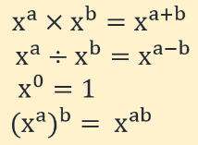  Index laws |  | Linear  Quadratic  Index  Indices  Factorise  Variable  Coefficient  Term  Expression  Simplify  Expand
Need more help? Use the Sparx Independent Learning Codes above.

